I CHOSE LIFE FOR MY DAUGHTER
When I discovered I was pregnant at 24, I felt my dreams had been shattered. I was single, living on a very small salary, and waiting to graduate.
I knew abortion was wrong, yet my fears made it seem like a real option. I was afraid of disappointing my parents, who had high hopes for me, and especially of facing them at graduation with an unplanned pregnancy.
Driven by fear, I decided to end the pregnancy. A friend directed me to a clinic where I told the doctor I wanted an abortion. He was willing to help, but after waiting for hours because he was busy with other patients, I lost patience and left.
I went to another clinic, Shalom Doctors Clinic. The many anti-abortion messages on the walls made me feel like I was in the wrong place. However, since the doctor had already welcomed me, I decided to speak with her.
Dr. Sandra listened as I shared my fears and assured her I was ready for an abortion. She explained the procedure and showed me video clips of abortion procedures. I was overwhelmed with emotion. I changed my mind and agreed with Dr. Sandra that I would give my baby a chance at life.
I shared my decision with my fellowship leader, Jjaja Alice Ssemasazi. She connected me to her daughter, Mrs. Lilian Nyakana, and her husband, Mr. Ronald Nyakana. From that time, they supported me throughout my pregnancy, delivery, and even to this day.
With their support, I also learned to trust God. This special verse has kept me going:
The LORD replied, ‘My Presence will go with you Moses (Racheal), and I will give you rest.’" (Exodus 33:14.) Everything will be fine for you.
At two and a half months pregnant, I graduated, but I still could not find a job. I left Kampala for a distant village in Wakiso District, where I experienced God’s presence and perfect rest. The Nyakanas welcomed and loved me, providing rent, food, clothes, a phone, and other necessities. They treated me like their own.
God also gave me skills in baking, crocheting, and hairdressing, which helped me earn a little money that I saved for delivery.
I delivered my baby safely. Months later, I told my parents about her. I sensed the news was difficult for them, and I ended the call in tears. When my daughter was one year old, I took her home, apologised to my parents for disappointing them, and was welcomed and forgiven.
They also welcomed my baby and gave her a cow.
Today, Baby Sherry is 9 years old. She is my favourite person in the whole world, my daily inspiration, and the love of my life. She is loved and cherished by almost everyone and is especially loved by my parents.
She is the reason I keep moving forward, regardless of the situation. She is the apple of my eye.
Rachel Komuhwezi
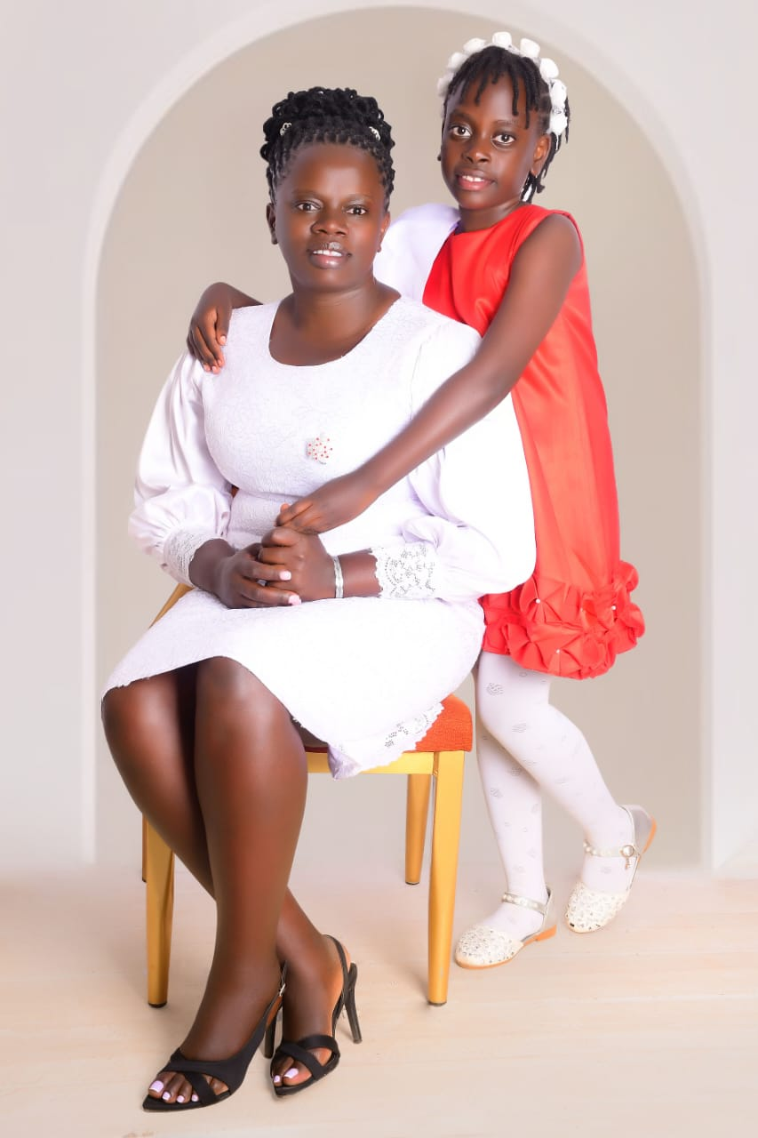
Highlight for the home page
“I went to a clinic intending to end my pregnancy. I walked out having made the most important decision of my life: to give my baby a chance.”
Racheal Komuhwezi

